Source https://www.getyourguide.com/bergen-l1132/from-bergen-modalen-private-fjords-cruise-with-waterfalls-t426044?ranking_uuid=d48b8d16-2243-4500-bf8b-3670be575270&date_from=2024-01-11&_pc=1,1
__________________________________________________________

Nordic Legends Voyage: Private Modalen Fjord Cruise from Bergen
__________________________________________________________
★★★★★ 4.9/5 20 reviews

Add to wishlist ♡

__________________________________________________________

7.5 hours | €350 per person (group up to 12 guests)

🏕  Image | 🏕  Image | 🏕  Image | 🏕  Image | 🏕  Image | 🏕  Image

__________________________________________________________
About This Tour
Set sail on an exclusive fjord expedition through Norway’s majestic wilderness with a private cruise from Bergen to the spectacular Modalen fjords. Designed for travelers seeking privacy, luxury, and awe-inspiring scenery, this experience combines dramatic mountain landscapes, cascading waterfalls, and charming remote villages. Relax on deck with fine wine, take a refreshing dip beneath a waterfall, and discover hidden corners of Norway that most visitors never see.
__________________________________________________________
What’s Waiting for You
- Duration: 7.5 hours
- Group Size: Private group (up to 12 guests)
- Languages Available: English
- Guide: Professional English-speaking captain/guide
- Transportation: Private boat experience
- Meeting Point: Strandkaien 3, 5013 Bergen (Tourist Information stand at Fish Market)
- Season: Available year-round (weather dependent)
__________________________________________________________

Check Dates & Availability

Select participants: (Age 99 and younger) - 1 +

Choose date:
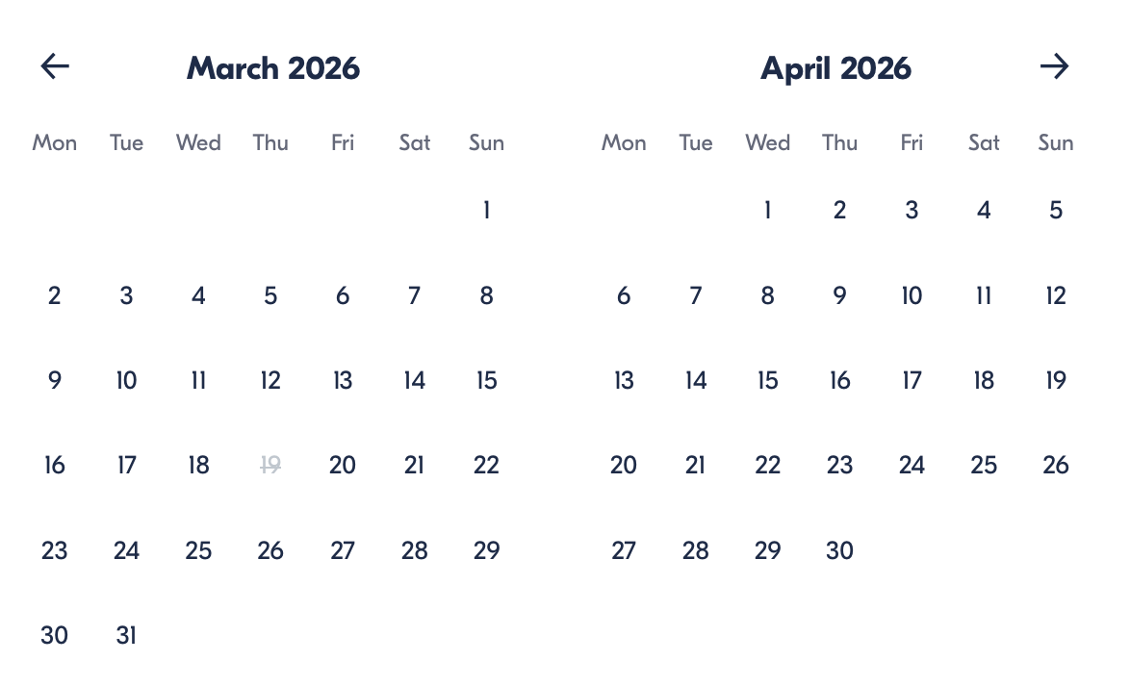

Check Availability

opens:

Participants: 12 March 16, 2026

Nordic Legends Voyage: Private Modalen Fjord Cruise from Bergen

- Duration: 7.5 hours
- Offered in: English
- Starts at: 9:30 AM

Cancellation:

- More than 24 hours before start — Full refund
- Less than 24 hours before start — No refund

Price breakdown: 12 Participants × €350

Total: €4,200

The total price includes all taxes and fees.

Add to cart Book now

__________________________________________________________
Tour Features
- Private Luxury Cruise: Enjoy complete privacy with your own captain and vessel.
- Waterfall Experience: Taste fresh mountain water or swim beneath a cascading waterfall.
- Modalen Village Stop: Explore one of Norway’s smallest villages at your own pace.
- Scenic Fjord Route: Pass picturesque towns like Sandviken and Eidsvåg.
- Onboard Comfort: Complimentary snacks, wine, coffee, tea, and beverages.
__________________________________________________________
Detailed Itinerary

1. Departure from Bergen Harbour
Your adventure begins as you head to the harbour to meet your captain and guide. As you depart, admire the UNESCO-listed Bryggen waterfront and Bergen’s iconic harbour scenery. Settle into your private boat while enjoying refreshments and music of your choice as the journey unfolds.

2. Cruising the Fjords
Glide through surreal landscapes of towering mountains, tranquil waters, and cascading waterfalls. Along the way, pass the charming districts of Sandviken and Eidsvåg while your guide shares stories and insights about the region’s nature and culture.

3. Modalen Fjord Experience
Arrive in the narrow fjords of Modalen, a remote region where nature dominates the horizon. Approach a waterfall close enough to feel the mist and taste pure mountain water. Adventurous guests may even swim beneath the falls, with hot showers and towels provided on board afterward.

4. Village of Mo Exploration
Stop in the tiny village of Mo, home to around 100 residents. Enjoy free time to explore this peaceful settlement, visit the local grocery store or café, and experience authentic rural Norwegian life far from the tourist crowds.

5. Final Fjord Highlights
Continue cruising toward a dramatic 90-meter waterfall near the cliffs of Fulufjallet National Park. Relax with snacks and drinks as the scenery unfolds around you. If you’re feeling adventurous, your captain may even let you steer the boat before returning to Bergen.
__________________________________________________________
Included in Price
- Private fjord cruise experience
- Experienced captain/guide
- Snacks onboard
- Wine and assorted beverages
__________________________________________________________
Not Included
- Lunch in Modalen village (optional)
- Personal expenses
__________________________________________________________
Who Should Avoid This Tour
- Travelers uncomfortable on boats for extended periods
- Guests sensitive to cold water or outdoor conditions
- Visitors requiring wheelchair access (boat access may be limited)
__________________________________________________________
Important Trip Info
- Bring a camera and a sense of adventure.
- Summer visitors can enjoy a café in Mo village or bring lunch.
- Weather conditions may affect the route or stops for safety.
- Swimming near waterfalls is optional and depends on conditions.
__________________________________________________________

Cancellation Policy
- More than 24 hours before start — Full refund
- 24 hours or less before start — No refund
__________________________________________________________
What Our Clients Are Saying

Overall rating  4.9/5  ★★★★★  Based on 20 reviews | Review summary  Guide 4.5/5  Transportation 4.6/5  Service 4.7/5  Organisation 4.5/5

Filter  - All traveller types  - Couples  - Group of friends  - Families  By star rating  - All star ratings  - 5 stars  - 4 stars  - 3 stars  - 2 stars  - 1 star | Search reviews (e.g., guide)  Sort by:  - Top picks  - Latest reviews  - Best ratings  - Lowest ratings
__________________________________________________________
★★★★★
James L. — United Kingdom
Absolutely breathtaking landscapes and an unforgettable waterfall experience. The captain made the day perfect.
★★★★★
Claire D. — France
Luxury, nature, and serenity combined. The private boat made it feel truly special.
★★★★★
Emma R. — United Kingdom
One of the best experiences in Norway. The scenery and hospitality were incredible.
★★★★★
Mikkel S. — Denmark
A dream fjord adventure. Swimming beneath the waterfall was unforgettable.
★★★★☆
Anna K. — Norway
Beautiful trip and very well organised. The village stop was charming and peaceful.
See more reviews
__________________________________________________________

Meta tags

Page - Nordic Legends Voyage: Private Modalen Fjord Cruise from Bergen

Title: Nordic Legends Voyage: Private Modalen Fjord Cruise from Bergen | Travellio Global

Description: Discover Norway’s spectacular fjords on a private Modalen cruise from Bergen. Enjoy waterfalls, scenic villages, drinks onboard, and unforgettable landscapes in total comfort.

H1 - Nordic Legends Voyage: Private Modalen Fjord Cruise from Bergen
__________________________________________________________

